**MINI PROJECT**

**(2020-21)**

### Build and Deploy an Application for Human pose Detection using Machine Learning and OpenCV.

**MID-TERM REPORT**



**Institute of Engineering & Technology**

**Submitted by-**

**Aditya Pandey**

**(181500043)**

**Mukul Joshi**

**(181500399)**

**Devansh Pandey**

**(181500212)**

***Supervised By: -***

### Ms. Priya Agarwal

Technical Trainer

### Department of Computer Engineering & Applications

### Contents

|  |  |
| --- | --- |
| **Abstract** | **3** |
| **1. Introduction** | **4** |
| 1.1 General Introduction to the topic | **4** |
| 1.2 Area of Computer Science | **5** |
| 1.3 Hardware and Software Requirements | **6** |
| **2. Problem definition** | **7** |
| **3. Objectives** | **8** |
| 4**. Implementation Details** | **11** |
| **5. Progress till Date & The Remaining work** | **11** |
| **6. Some Screenshots** | **12** |
| **7. Reference** | **13** |

## Abstract

**Human Pose detection is an important problem that has enjoyed the attention of the Computer Vision community for the past few decades. It is a crucial step towards understanding people in images and videos. In this post, I write about the basics of Human Pose Estimation (2D) and review the literature on this topic.**

## Introduction

### General Introduction to the topic

A Human Pose Skeleton represents the orientation of a person in a graphical format. Essentially, it is a set of coordinates that can be connected to describe the pose of the person. Each co-ordinate in the skeleton is known as a part (or a joint, or a keypoint). A valid connection between two parts is known as a pair (or a limb). Note that, not all part combinations give rise to valid pairs. A sample human pose skeleton is shown below.

1. Image for post

## What is Human Pose Estimation?

**Human Pose Detection**is defined as the problem of localization of human joints (also known as keypoints - elbows, wrists, etc) in images or videos. It is also defined as the search for a specific pose in space of all articulated poses.

**2D Pose Detection** - Estimate a 2D pose (x,y) coordinates for each joint from a RGB image.

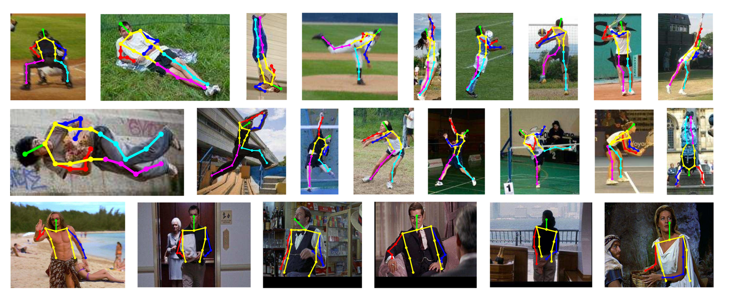

**Area of Computer Science**

The area of computer science in human pose detection has some pretty cool applications and is heavily used in Action recognition, Animation, Gaming, etc. For example, a very popular Deep Learning app [HomeCourt](https://www.homecourt.ai/" \o "Opens in a new window" \t "_blank) uses Pose Estimation to analyse Basketball player movements.

* 1. **Hardware requirements**
* **A Webcam of Laptop/ Computer is used.**

#### 1.3 Software requirements

* OpenCV is used.
* Use of Python language.
* Tensor Flow is used.

**Objective**

The main objective is to construct a system which takes video as an input to read and analyse and provide us the activity performed by a human being in it in the English language as output.

# SCREENSHOTS

–––––-–––––

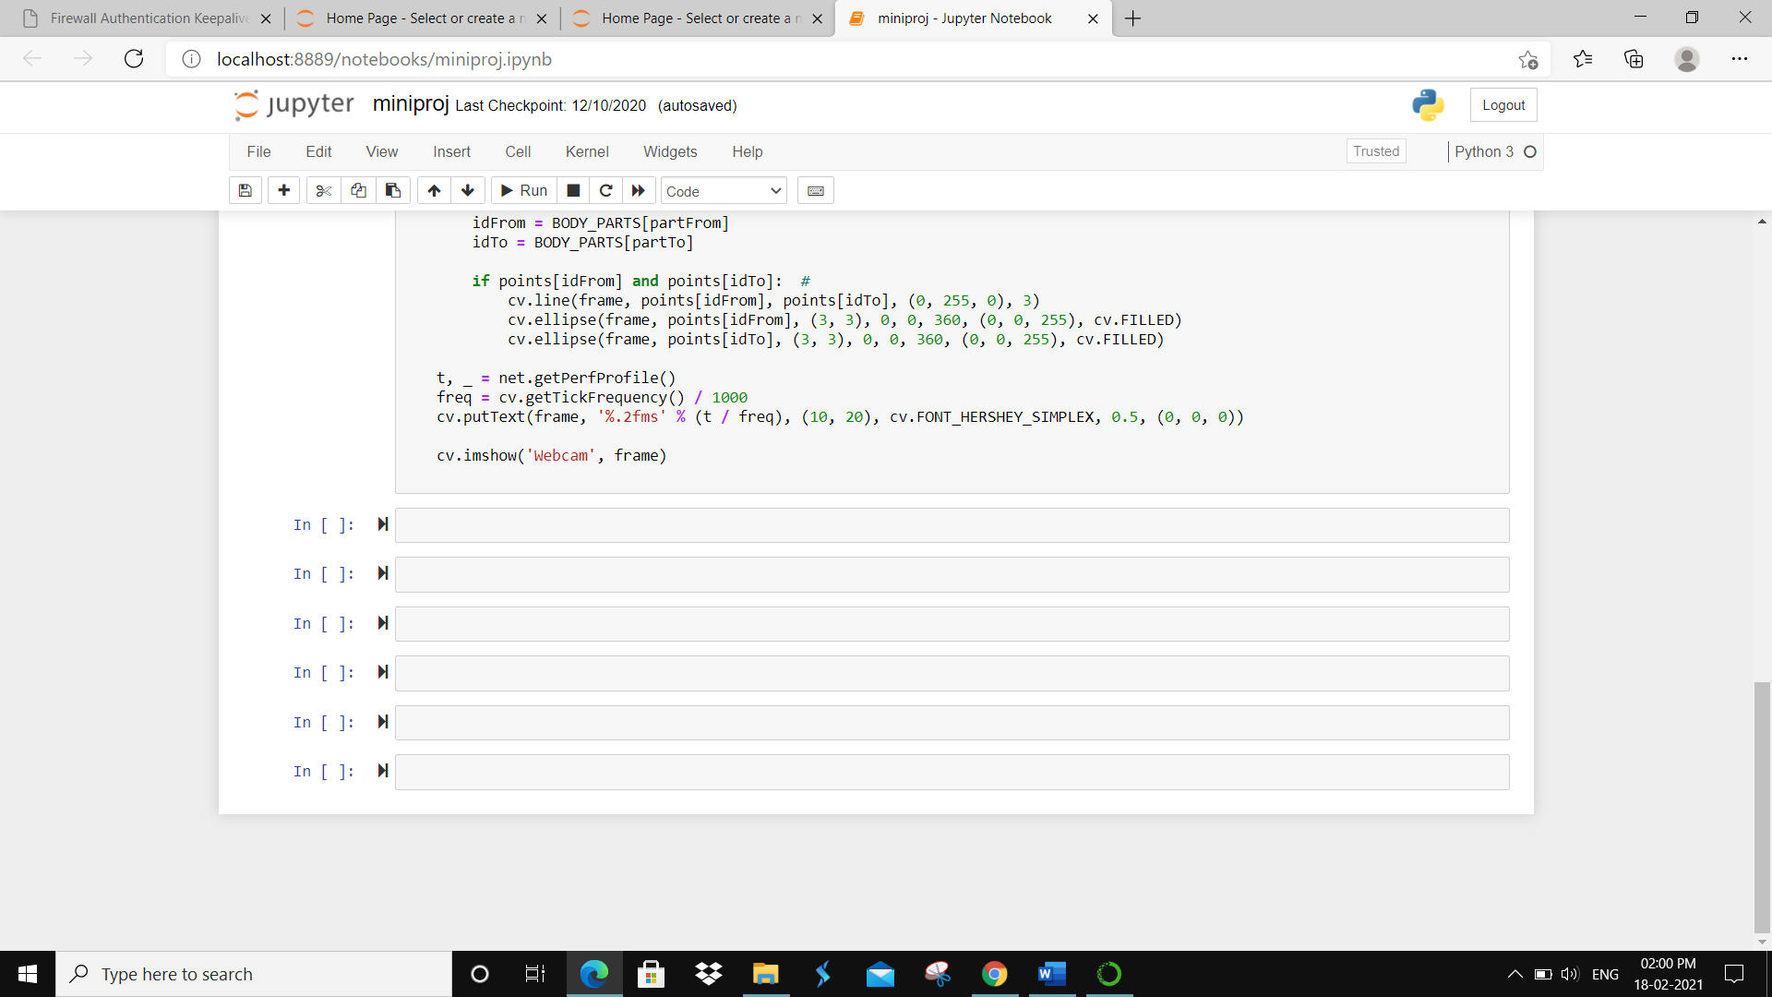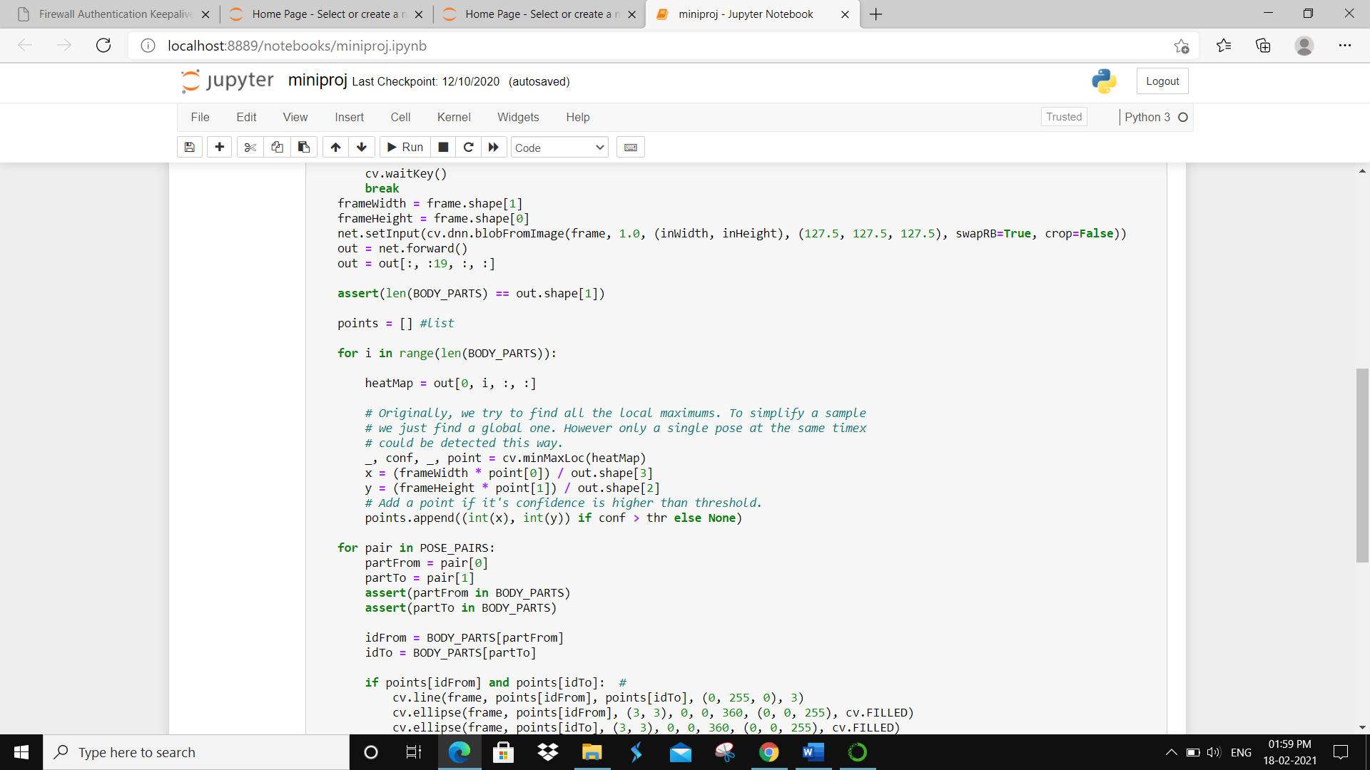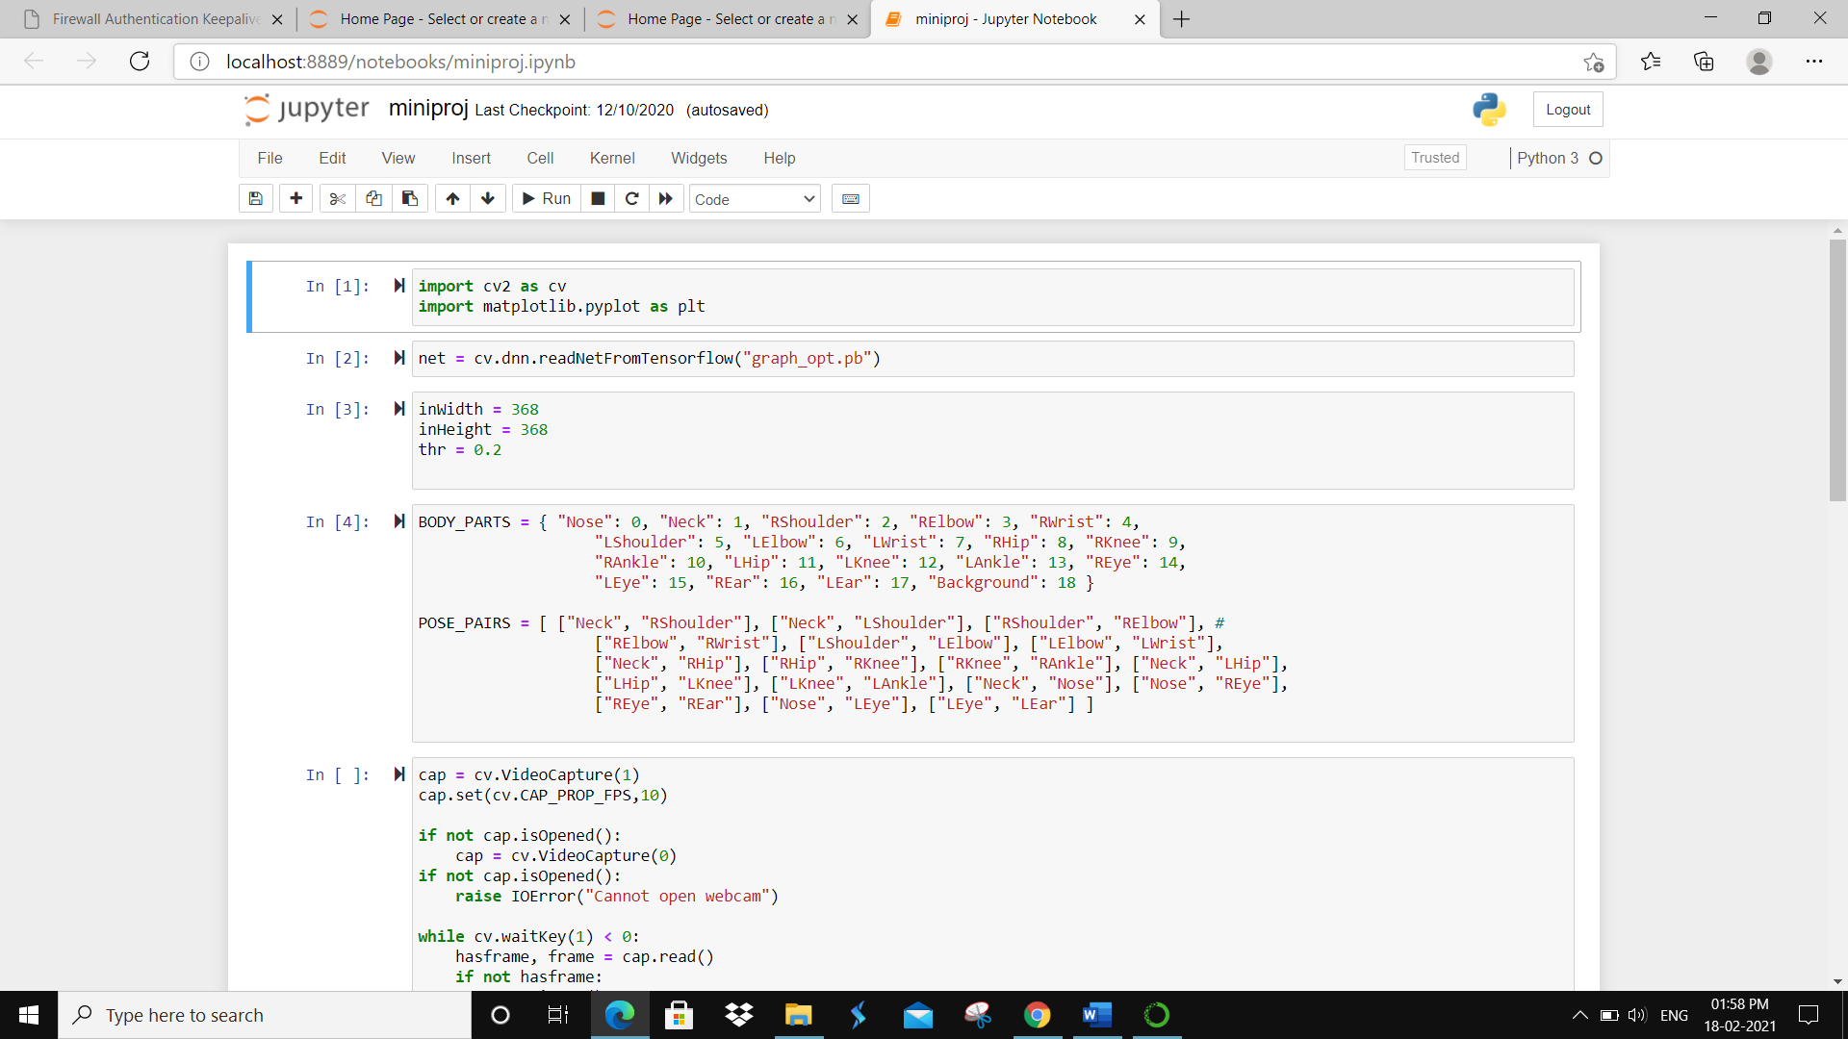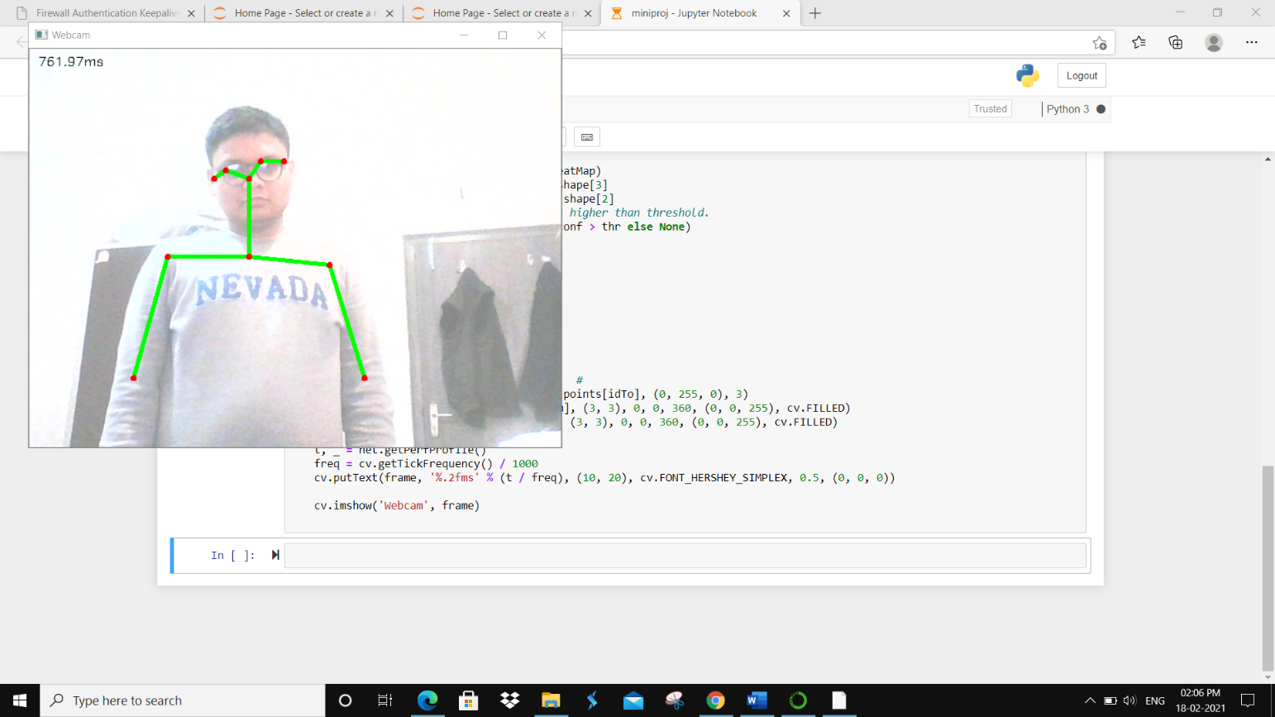

**Reference**

<https://www.nanonets.com/blog/human> -pose- detection-2-D-guide/